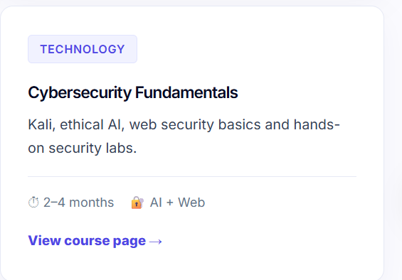

Change : Kali, ethical AI, web security basics
to : Kali Linux, ethical hacking, web security fundamentals and hands-on security labs.

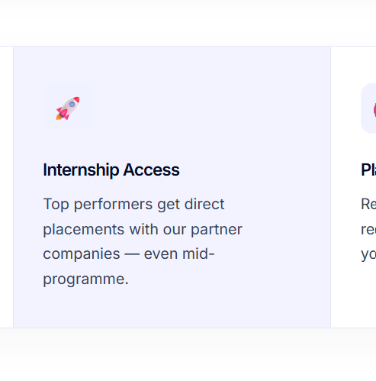
Top performers get direct placements with our partner companies — even mid-programme.

Change to Top students placed with partner companies during the programme. Or Eligible students receive interview preparation, job referrals and continued placement guidance.

Leading SAP Institute
Maybe:
Industry-focused SAP & IT Training Institute

Check address as well; maintain same address everywhere

Performance issues :

Homepage HTML is large.
Maybe use Separate CSS, JavaScript, Images

Check these :Student receives acknowledgement email, Admin receives enquiry, SMTP works, Error handling, Spam protection, Validation, Duplicate submissions

Priority :
Google Search Console
Google Business Profile
Analytics
Blog
Local SEO
Faculty Profiles
Classroom Photos
Student Success Stories
Refactor homepage CSS
Refactor homepage JS
Image optimisation
Accessibility improvements
Additional FAQ pages

Resume Building
Mock Interviews
Technical Preparation
HR Preparation
Job Referrals
Placement Support

